

|  |
| --- |
| School of Computing  Faculty of Engineering AND PHYSICAL SCIENCES |

Machine learning and Multimodal Deep learning Classifiers for aneurysm rupture risk prediction

Wenjie Zhang

Submitted in accordance with the requirements for the degree of  
Msc Advanced Computer Science

**2023/2024**

The candidate confirms that the following have been submitted*:*

*<As an example>*

|  |  |  |
| --- | --- | --- |
| **Items** | **Format** | **Recipient(s) and Date** |
| *Deliverables 1, 2, 3* | *Report* | *SSO (xx/xx/xx)* |
| *Participant consent forms* | *Signed forms in envelop* | *SSO (xx/xx/xx)* |
| *Deliverable 4* | *Software codes or URL* | *Supervisor, assessor (xx/xx/xx)* |
| *Deliverable 5* | *User manuals* | *Client, supervisor (xx/xx/xx)* |

Type of Project: ____________________________________

The candidate confirms that the work submitted is their own and the appropriate credit has been given where reference has been made to the work of others.

I understand that failure to attribute material which is obtained from another source may be considered as plagiarism.

(Signature of student)

© 2024 The University of Leeds and <full name of candidate>

# Summary

*<Concise statement of the problem you intended to solve and main achievements (no more than one A4 page)>*

***<Reminder about basic requirements of layout and format:***

***The report must be in typescript, sequentially page numbered, on A4, single or double-sided, with 1in margins. Point size 11 and one-and-a-half line spacing should be used.***

***Page Numbering: The pages preceding the body of the text, i.e. from "Summary" to "Contents" inclusive, should be sequentially numbered in Roman numerals. All the remaining pages should be numbered in a single sequence of Arabic numerals.***

***Length: The main body of a 60 credit project report must be no longer than 60 pages (i.e. excluding appendices and references). The limit for 40-credit projects is 50 pages.>***

# Acknowledgements

*<This page should contain any acknowledgements to those who have assisted with your work. Where you have worked as part of a team, you should, where appropriate, reference to any contribution made by others to the project.*

*Note that it is not acceptable to solicit assistance on ‘proof reading’ which is defined as “the systematic checking and identification of errors in spelling, punctuation, grammar and sentence construction, formatting and layout in the text”; see* [*http://www.leeds.ac.uk/qat/documents/policy/Proof-reading-policy.pdf*](http://www.leeds.ac.uk/qat/documents/policy/Proof-reading-policy.pdf)*. >*

# Table of Contents

Summary iii

Acknowledgements iv

Table of Contents v

Chapter 1 Level 1 Heading with ‘heading 1’ Style Applied by Pressing Ctrl Shift 1 1

1.1 Level 2 Heading with ‘heading 2’ Style Applied by Pressing Ctrl Shift 2 1

1.1.1 Level 3 Heading with ‘heading 3’ Style Applied by Pressing Ctrl Shift 3 1

1.1.1.1 Level 4 Heading with ‘heading 4’ Style Applied by Pressing Ctrl Shift 4 1

Chapter 2 Tables and Figures 2

2.1 Tables using the ‘table caption’ and ‘table description’ Styles 2

2.2 Figures using the ‘figure caption’ and ‘figure description’ Styles 2

List of References 3

Appendix A External Materials 4

A.1 Level 2 Heading with ‘heading 2’ Style Applied by Pressing Ctrl Shift 2 4

A.1.1 Level 3 Heading with ‘heading 3’ Style Applied by Pressing Ctrl Shift 3 4

A.1.1.1 Level 4 Heading with ‘heading 4’ Style Applied by Pressing Ctrl Shift 4 4

Appendix B Ethical Issues Addressed 5

B.1 Level 2 Heading 5

# Chapter 1 Introduction and Background research

## 1.1 Introduction

Intracranial aneurysm (IA) is a cerebrovascular disease that primarily affects the cerebral arteries and is characterized by the pathological dilation of blood vessels [3][6]. IA has become more common nowadays, affecting approximately three out of every hundred people, with each patient's IA carrying a risk of rupture, potentially leading to death [2]. This has motivated me to undertake this project aimed at assisting doctors and researchers currently working on treating IA, as well as addressing some of the recently identified challenges in this field.

## 1.2 Background Research

### 1.2.1 Problem statement and motivation

As the condition we stated in the last section, a patient's intracranial aneurysm (IA) carries a risk of rupturing which will lead to death, which means an Unruptured intracranial aneurysm (UIA) becomes a life-threaten condition, making the treatment for it become more important nowadays. However, UIA treatments such as neurosurgical clipping and endovascular coiling carry the risk of causing the IA to rupture [11]. Therefore, accurately assessing the rupture risk of UIA is crucial before determining the appropriate treatment plan for each patient.

Upon reviewing some past research on assessing IA rupture risk [8][9], we found out that the rupture risk of UIA depends on multiple factors of the IA and patient. As a computer science student, we believe there exist suitable computer science methods and algorithms that can measure the UIA rupture risk based on these factors. Furthermore, by addressing the gaps and limitations in previous research, we can propose an improved method for assessing the risk of UIA rupture.

These considerations have motivated me to undertake this project, which aimed to give a proper way to predict the possibility of rupture for patients’ IA using computer science algorithms and methods, so the doctor or hospital can give these patients some appropriate treatment plans and surgeries.

### 1.2.2 Possible solution

Through some literature research, we found some recent research about predicting the IA focus on machine learning[1][7], they train the machine learning model using the parameters that related to the shape of the IA and patient status to predict the rupture risk of the IA; there also some other researches were using deep learning models such as common Deep learning neural network (DNN) and convolutional neural network (CNN) [12][13], they feed the model with images that been taken from different angles of 3D modelled IA and predict the rupture or risk of the IA. Furthermore, recent research by H.Chao[14], uses the AneuX morphology database[15] with 750 IA samples and their 3D models to train a Point cloud-based Deep learning model called PointNet++ [17].

### 1.2.3 Database chosen

By looking through the research above, we conclude the way to predict the UIA rupture risk using the factors of IA patients is best achieved through some machine learning and deep learning models. The AneuX morphology database, a publicly available resource, includes 750 IA samples and 3D models from various hospitals. Each sample has 170 different morphometric parameters computed for the aneurysm models, which accurately describe the shape of IAs and are well-suited for feeding into machine learning and deep learning models. These characteristics make the AneuX morphology database an ideal choice as the database for training these models. Consequently, it has been selected in this project as the dataset to test the different models as well as to compare the performance.

Additonally, the format of the raw data from the AneuX morphology database might not be suitable for direct input into machine learning and deep learning models. Therefore, based on the input format requirements of these models, some data preprocessing will be necessary.

### 1.2.3 Machine learning methods

Previous research [1][7] has shown that some machine learning methods perform well with around 80% accuracy on some IA datasets when fed with morphological parameters of IAs and patient information only. This suggests that some proper machine learning models can be trained using the AneuX morphology database and might give a good prediction. Moreover, research by Detmer FJ. et al.[18] did a comparison for a previously developed IA rupture logistic regression model (LRM) with some machine learning classifiers and concluded the performance for these models. Therefore, based on Detmer FJ's findings, the classifiers that demonstrated suitable performance have been selected for this project. These include logistic regression, Lasso regression, Ridge regression and Random Forest. The aim is to compare and evaluate the performance of the classifiers when used on the AneuX database. Furthermore, some other simple machine learning models, such as ordinary least squares linear regression, have been included for comparison to provide a comprehensive evaluation of different machine learning approaches.

### 1.2.4 Deep learning methods

Another research by Mirzat Turhon. et al.[12] has concluded a result that the Deep learning models outperform the traditional machine learning models in predicting UIA rupture risk using radionics and morphological parameters. Considering that this condition might also be the case when using the AneuX morphology database, deep-learning models have been included in this project.

We also discovered that most recent research focuses on using convolutional neural networks (CNNs) for predicting UIA properties [1][12][13]. However, it is suggested that other deep-learning networks might perform better than CNNs. Given that the AneuX database includes 3D models of the IAs, it is feasible to use these 3D models as input for deep learning models designed for such data. These deep learning models might perform differently compared to those using morphological parameters as input.

There is some recent research that focuses on feeding 3D models into deep learning models by converting the brain vessel and IA models into point clouds [22][23]. These studies have used point-cloud data to train models such as PointNet [16], PointNet++ [17], So-Net [19], SpiderCNN [20], and other 3D point cloud deep learning models. The results of these models show good performance in predicting various features of IA. This approach leverages the detailed spatial information present in the 3D models that the morphological parameters cannot provide, potentially providing more accurate predictions of UIA rupture risk.

For instance, H.Chao[14] used the point cloud model of IA to predict rupture risk on the AneuX dataset by training the PointNet++ [17] model, achieving a result of approximately 79% accuracy for the internal dataset test. However, their study did not validate the performance of the basic PointNet. As the Figure shows [Figure 1], since the PointNet++ is a model based on adding some extra layers to the basic PointNet, and it is a relatively larger complex model compared to PointNet, these additional layers of the PointNet++ over then PointNet might not necessarily improve performance and could even negatively impact it. Thus, PointNet++ may not be the optimal model for this task. Consequently, we decide to train an IA classification PointNet to test the performance of using IA 3D models in the Aneux dataset for predicting the IA rupture risk and, additionally, to explore possible improvements to the model.

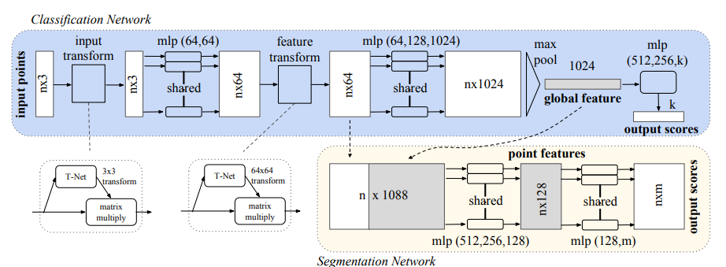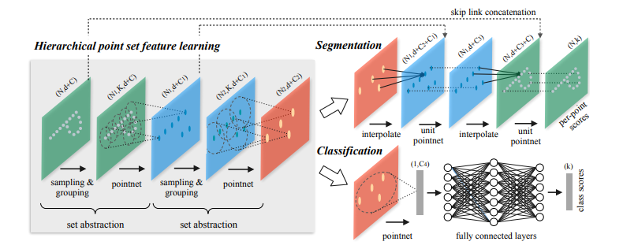*Figure 1: PointNet[16] and PointNet++[17] model structure*

Furthermore, we found that some studies use deep learning models that can be fed with different types of inputs simultaneously [2][21][22][24]. These models are designed to handle different inputs through separate subnetworks, merging the outputs at some point before feeding the combined result into subsequent layers to produce the final output [*Figure 2, Figure 3*].

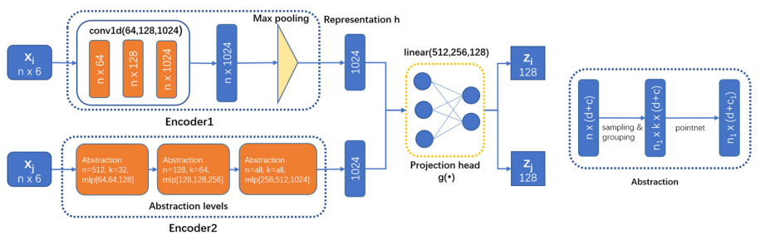*Figure 2:* D. Shao, X. Lu and X. Liu Dual-Branch Learning model [22]

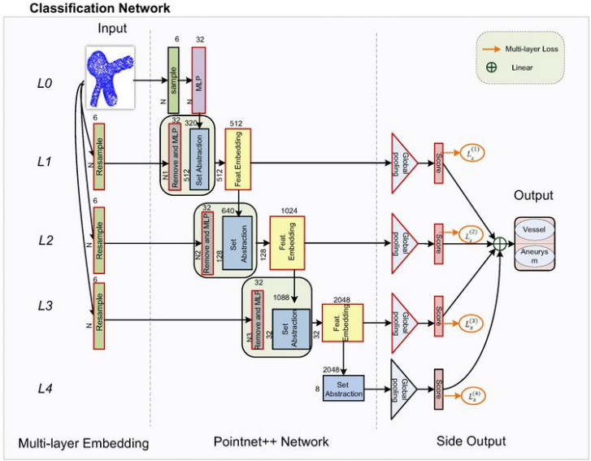

*Figure 3:* Wang J, Liu J, Xu Z, et al. N-PointNet multi-layer model [21]

Different research studies refer to these methods with various names, such as dual-branch [22] and multi-stream [24], but they all perform similar functions by processing different inputs separately and then merging the outputs to combine the information for the deep learning model to learn. These approaches inspired us to enhance the IA classification PointNet model by incorporating outputs from models fed with morphometric parameters or other relevant point cloud models, such as models for brain vessels.

We propose a multi-modal model, or a multi-branch model, based on PointNet. This model will integrate additional information by combining outputs from different input sources at a specific point in the original PointNet structure. We will then test and evaluate whether our enhanced model delivers better performance than the original PointNet. By leveraging the strengths of both morphometric parameters and 3D point cloud data, we aim to improve the accuracy and reliability of UIA rupture risk predictions.

### 1.2.5 Background research summary

IA has been a real life-threaten decease nowadays, and accurate prediction of UIA rupture risk is crucial for determining the appropriate treatment plans. This project aims to address this by leveraging machine learning and deep learning methods, particularly focusing on the AneuX morphology database, which offers comprehensive morphometric data and 3D models of IAs.

Machine learning models such as logistic regression, Lasso regression, Ridge regression, and Random Forest have shown promising results in previous studies. By applying these models to the AneuX dataset, we aim to compare their performance and identify the best approach. Additionally, simple models like ordinary least squares linear regression will be included to provide a baseline for comparison.

Deep learning methods, particularly those utilizing 3D models, are also considered. Recent advancements have shown that models such as PointNet and PointNet++ can effectively process point cloud data that convert from original 3D modal to predict IA rupture risk. This project will test the basic PointNet model and explore enhancements through multi-modal approaches that integrate morphometric parameters and 3D point cloud data, evaluate the potential changes or improvement on the performance.

In summary, this project combines machine learning and deep learning techniques to develop a robust method for predicting UIA rupture risk. By evaluating different models and leveraging the comprehensive data in the AneuX morphology database, we aim to provide valuable methods for doctors and researchers to improve IA treatment and patient outcomes.

## 1.3 Aim

Compare Deep learning and Machine Learning methods result on the risk prediction, choose a suitable model for the risk prediction.

Come up with idea that can improve the prediction result

# Chapter 3 Experiment and Models setup

3.1 Code and lib using

3.2 Data preprocessing

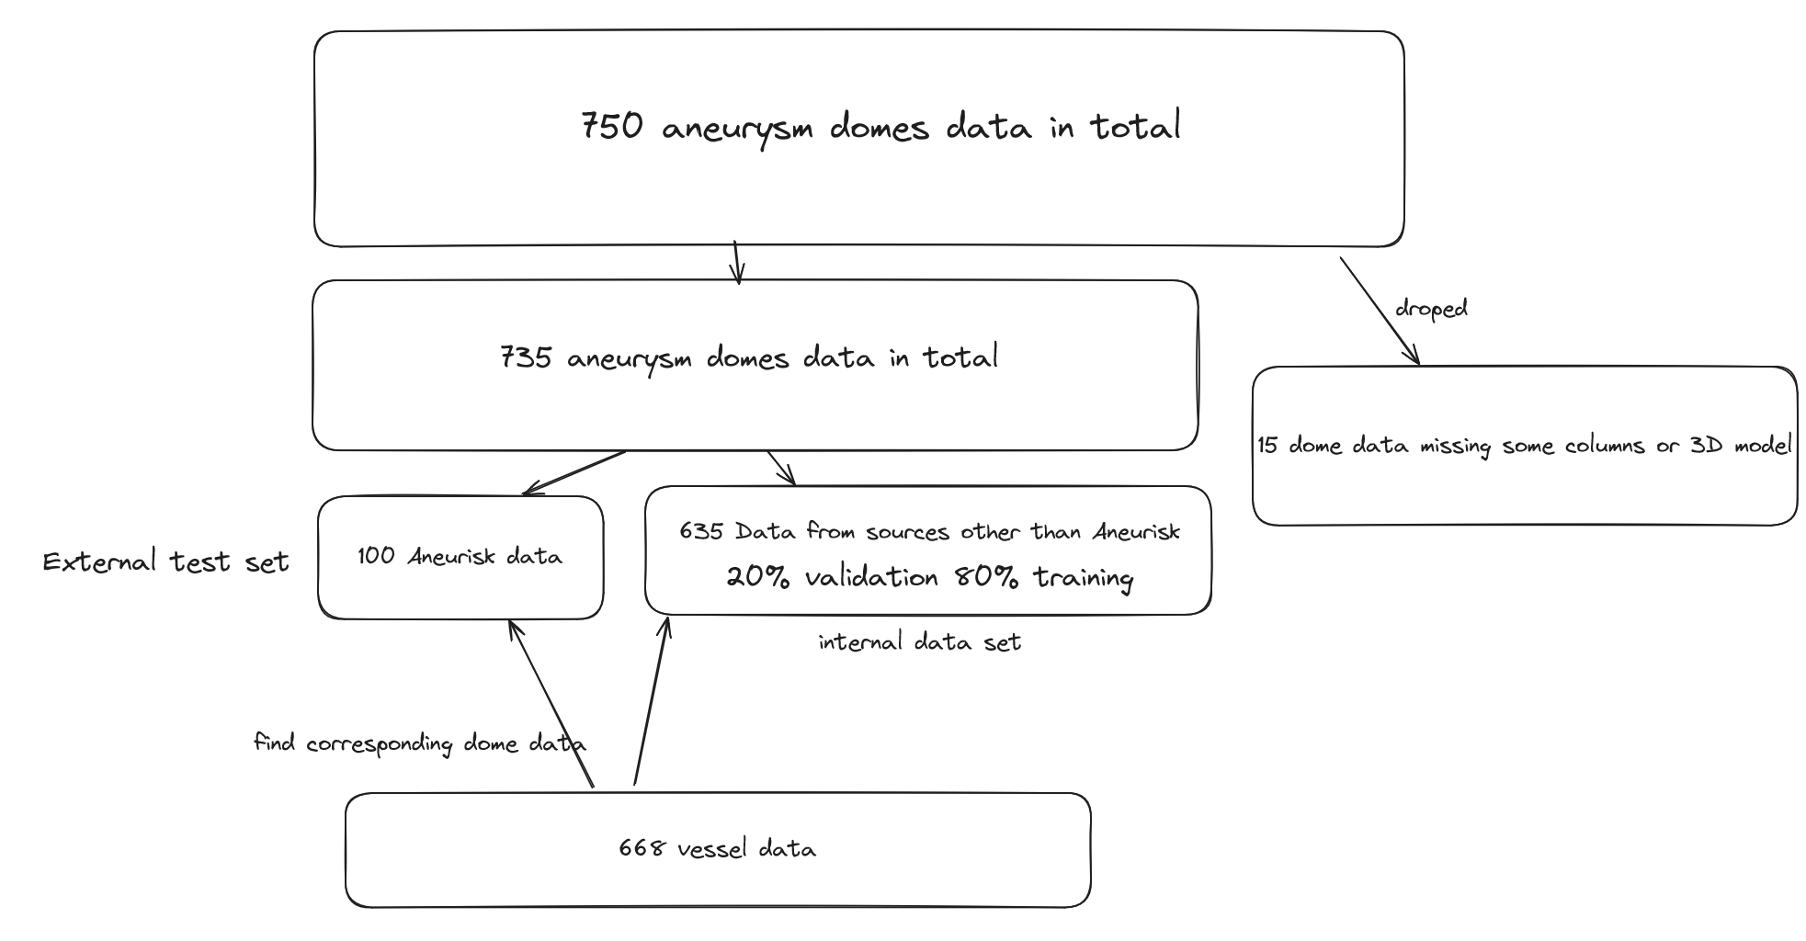#explaination of the data split

split the raw data, delete the patient that missing data

Morph parameter used for machine learning and basic DNN

Data turn in to points for point Net (poisson disk and Triangle based)

3.2 DNN and Point Net Model

Basic 3 layer DNN

PointNet Model

3.3 Multimodal PointNet

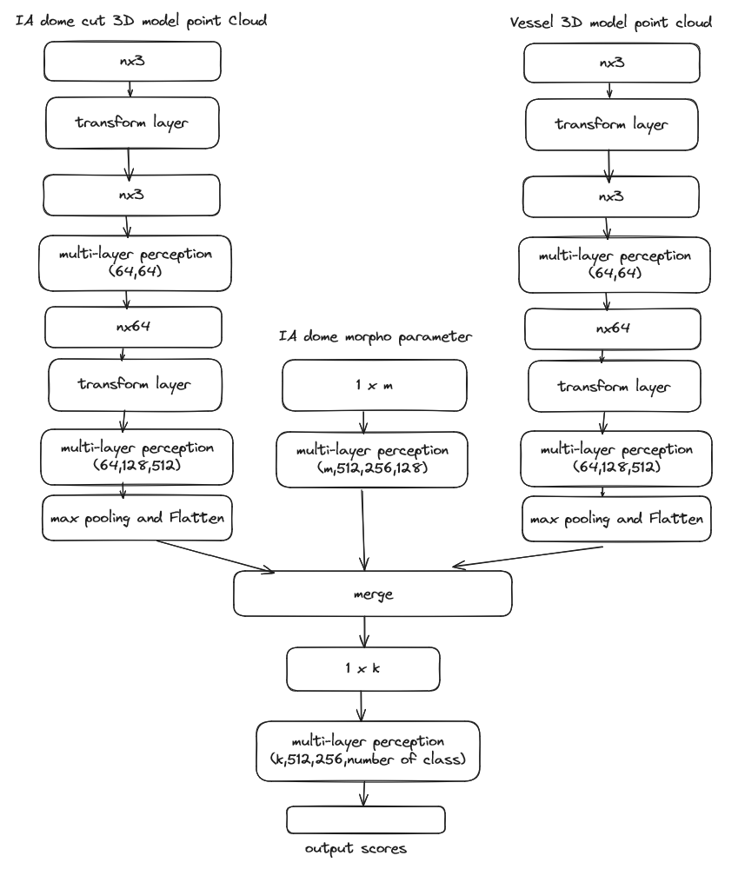Diagram NumberX: Multimodal PointNet

3.2 Experiment Set up

The computer resource used for training the model

The batch size, the learning rate, the loss weight

# Chapter 4 Result and Evaluation

4.1 Machine learning Result

|  |  |  |  |  |  |  |  |
| --- | --- | --- | --- | --- | --- | --- | --- |
| Model | Accuracy  (± 2%) | F1-score  (± 0.02) | Rupture Recall  (± 0.03) | Rupture Precision  (± 0.03) | Unrupture Recall  (± 0.03) | Unrupture Precision  (± 0.02) | AUC  (± 0.02) |
| OLS | 67.7% | 0.511 | 0.512 | 0.5 | 0.755 | 0.764 | 0.64 |
| Lasso | 72.8% | 0.35 | 0.243 | 0.625 | **0.93** | 0.72 | 0.65 |
| Ridge | 74.2% | 0.552 | 0.512 | 0.6 | 0.837 | 0.782 | 0.68 |
| Logistic | 73.2% | **0.575** | 0.560 | 0.589 | 0.813 | 0.795 | 0.66 |
| Random Tree | **77.1%** | 0.567 | 0.463 | **0.73** | **0.918** | 0.782 | 0.69 |
| Random Forest | 74.0% | 0.53 | 0.463 | 0.633 | 0.872 | 0.773 | **0.70** |
| 3-layer Neural Network | 72.5% | 0.582 | **0.657** | 0.522 | 0.753 | **0.842** | **0.76** |

Table NumberX: Machine learning models’ internal test result

|  |  |  |  |  |  |  |  |
| --- | --- | --- | --- | --- | --- | --- | --- |
| Model | Accuracy  (± 2%) | F1-score  (± 0.04) | Rupture Recall  (± 0.03) | Rupture Precision  (± 0.04) | Unrupture Recall  (± 0.02) | Unrupture Precision  (± 0.02) | AUC  (± 0.02) |
| OLS | 54.4% | 0.361 | 0.295 | 0.464 | 0.736 | 0.575 | 0.48 |
| Lasso | 56.0% | 0.225 | 0.159 | 0.543 | **0.912** | 0.584 | 0.53 |
| Ridge | 55.4% | 0.383 | 0.318 | 0.482 | 0.732 | 0.577 | 0.55 |
| Logistic | 58.2% | 0.432 | **0.363** | 0.533 | 0.75 | 0.6 | 0.57 |
| Random Tree | 58% | 0.45 | 0.340 | **0.681** | **0.875** | 0.628 | 0.58 |
| Random Forest | **61%** | **0.463** | **0.363** | 0.64 | 0.839 | 0.626 | **0.58** |
| 3-layer Neural Network | 52.5% | 0.272 | 0.461 | 0.19 | 0.541 | **0.808** | 0.54 |

Table NumberX: Machine learning models’ external test result

#machine learning result explaination

4.2 DNN PointNet and Multimodal PointNet Model result

Model structure, Idea of the model

3 layer NN (with batch normalization)

PointNet:

2000 points vs 1000 points

1000 points Fps vs uniform sampling

1000 points 3 branch multimodal vs 2 branch multimodal vs 2 branch vs pointNet

|  |  |  |  |  |  |  |
| --- | --- | --- | --- | --- | --- | --- |
| Model  (vessel + IA) | points | F1-score  (± 0.04) | Rupture Recall  (± 0.03) | Rupture Precision  (± 0.04) | Unrupture Recall  (± 0.02) | Unrupture Precision  (± 0.02) |
| PointNet  (uniform) | 1000 | 0.438 | 0.4 | 0.484 | 0.804 | 0.744 |
| 2000 | 0.533 | 0.551 | 0.516 | 0.776 | 0.8 |
| 2-Branch  (uniform) | 1000 | 0.693 | 0.85 | 0.586 | 0.724 | 0.913 |
| 2000 | 0.645 | 0.689 | 0.606 | 0.805 | 0.857 |
| PointNet  (ppd) | 1000 | 0.411 | 0.35 | 0.5 | 0.839 | 0.737 |
| 2000 | 0.444 | 0.413 | 0.48 | 0.805 | 0.760 |
| 2-Branch  (ppd) | 1000 | 0.643 | 0.7 | 0.595 | 0.781 | 0.85 |
| 2000 | 0.636 | 0.724 | 0.567 | 0.761 | 0.864 |

|  |  |  |  |
| --- | --- | --- | --- |
| Model (vessel + IA) | points | Accuracy | AUC |
| PointNet  (uniform) | 1000 | 67.7% | 0.61 |
| 2000 | 70.8% | 0.76 |
| 2-Branch  (uniform) | 1000 | 76.3% | 0.83 |
| 2000 | 77% | 0.83 |
| PointNet  (ppd) | 1000 | 68.5% | 0.65 |
| 2000 | 68.7% | 0.65 |
| 2-Branch  (ppd) | 1000 | 75.5% | 0.84 |
| 2000 | 75% | 0.85 |

Table NumberX: PointNet models’ internal test result

|  |  |  |  |
| --- | --- | --- | --- |
| Model (vessel + IA) | points | Accuracy | AUC |
| PointNet  (uniform) | 1000 | 52% | 0.46 |
| 2000 | 57% | 0.52 |
| 2-Branch  (uniform) | 1000 | 55% | 0.51 |
| 2000 | 53% | 0.56 |
| PointNet  (ppd) | 1000 | 54% | 0.54 |
| 2000 | 55% | 0.56 |
| 2-Branch  (ppd) | 1000 | 59% | 0.49 |
| 2000 | 60% | 0.59 |

Table NumberX: PointNet models’ external test result

|  |  |  |  |  |  |  |
| --- | --- | --- | --- | --- | --- | --- |
| Model (vessel + IA) | points | F1-score  (± 0.02) | Rupture Recall  (± 0.03) | Rupture Precision  (± 0.04) | Unrupture Recall  (± 0.02) | Unrupture Precision  (± 0.04) |
| PointNet  (uniform) | 1000 | 0.399 | 0.363 | 0.444 | 0.642 | 0.562 |
| 2000 | 0.358 | 0.272 | 0.521 | 0.803 | 0.584 |
| 2-Branch  (uniform) | 1000 | 0.383 | 0.318 | 0.482 | 0.732 | 0.577 |
| 2000 | 0.338 | 0.272 | 0.444 | 0.732 | 0.561 |
| PointNet  (ppd) | 1000 | 0.281 | 0.204 | 0.45 | 0.803 | 0.562 |
| 2000 | 0.307 | 0.227 | 0.476 | 0.803 | 0.569 |
| 2-Branch  (ppd) | 1000 | 0.422 | 0.340 | 0.555 | 0.785 | 0.602 |
| 2000 | 0.487 | 0.431 | 0.558 | 0.732 | 0.621 |

Table NumberX: PointNet models’ external test result

|  |  |  |  |  |  |  |
| --- | --- | --- | --- | --- | --- | --- |
| Model  (dome) | points | F1-score  (± 0.04) | Rupture Recall  (± 0.03) | Rupture Precision  (± 0.04) | Unrupture Recall  (± 0.02) | Unrupture Precision  (± 0.02) |
| PointNet  (uniform) | 1000 | 0.271 | 0.2 | 0.421 | 0.873 | 0.703 |
| 2000 | 0.448 | 0.379 | 0.55 | 0.865 | 0.763 |
| 2-Branch  (uniform) | 1000 | 0.513 | 0.475 | 0.558 | 0.827 | 0.774 |
| 2000 | 0.656 | 0.724 | 0.6 | 0.791 | 0.868 |
| PointNet  (ppd) | 1000 | 0.393 | 0.325 | 0.5 | 0.850 | 0.732 |
| 2000 | 0.272 | 0.206 | 0.4 | 0.865 | 0.716 |
| 2-Branch  (ppd) | 1000 | 0.578 | 0.55 | 0.611 | 0.839 | 0.802 |
| 2000 | 0.666 | 0.724 | 0.617 | 0.805 | 0.870 |

|  |  |  |  |
| --- | --- | --- | --- |
| Model  (dome) | points | Accuracy | AUC |
| PointNet  (uniform) | 1000 | 66.1% | 0.61 |
| 2000 | 71.8% | 0.67 |
| 2-Branch  (uniform) | 1000 | 71% | 0.81 |
| 2000 | 77% | 0.86 |
| PointNet  (ppd) | 1000 | 68.5% | 0.61 |
| 2000 | 66.6% | 0.59 |
| 2-Branch  (ppd) | 1000 | 74.8% | 0.82 |
| 2000 | 78.1% | 0.86 |

Table NumberX: PointNet models’ internal test result

|  |  |  |  |  |  |  |
| --- | --- | --- | --- | --- | --- | --- |
| Model  (dome) | points | F1-score  (± 0.04) | Rupture Recall  (± 0.03) | Rupture Precision  (± 0.04) | Unrupture Recall  (± 0.02) | Unrupture Precision  (± 0.02) |
| PointNet  (uniform) | 1000 | 0.190 | 0.136 | 0.315 | 0.767 | 0.530 |
| 2000 | 0.237 | 0.159 | 0.466 | 0.857 | 0.564 |
| 2-Branch  (uniform) | 1000 | 0.258 | 0.181 | 0.444 | 0.821 | 0.560 |
| 2000 | 0.258 | 0.181 | 0.444 | 0.821 | 0.560 |
| PointNet  (ppd) | 1000 | 0.272 | 0.204 | 0.409 | 0.767 | 0.551 |
| 2000 | 0.205 | 0.159 | 0.291 | 0.696 | 0.513 |
| 2-Branch  (ppd) | 1000 | 0.241 | 0.159 | 0.5 | 0.875 | 0.569 |
| 2000 | 0.338 | 0.25 | 0.523 | 0.821 | 0.582 |

|  |  |  |  |
| --- | --- | --- | --- |
| Model (dome) | points | Accuracy | AUC |
| PointNet  (uniform) | 1000 | 49% | 0.37 |
| 2000 | 55% | 0.46 |
| 2-Branch  (uniform) | 1000 | 54% | 0.50 |
| 2000 | 54% | 0.50 |
| PointNet  (ppd) | 1000 | 52% | 0.50 |
| 2000 | 46% | 0.49 |
| 2-Branch  (ppd) | 1000 | 56% | 0.60 |
| 2000 | 57% | 0.54 |

Table NumberX: PointNet models’ external test result

|  |  |  |  |  |  |  |
| --- | --- | --- | --- | --- | --- | --- |
| Model  (cut1) | points | F1-score  (± 0.04) | Rupture Recall  (± 0.03) | Rupture Precision  (± 0.04) | Unrupture Recall  (± 0.02) | Unrupture Precision  (± 0.02) |
| PointNet  (uniform) | 1000 | 0.280 | 0.2 | 0.470 | 0.896 | 0.709 |
| 2000 | 0.416 | 0.344 | 0.526 | 0.865 | 0.753 |
| 2-Branch  (uniform) | 1000 | 0.666 | 0.7 | 0.636 | 0.816 | 0.855 |
| 2000 | **0.757** | **0.862** | **0.675** | **0.820** | **0.932** |
| PointNet  (ppd) | 1000 | 0.324 | 0.3 | 0.352 | 0.747 | 0.698 |
| 2000 | 0.307 | 0.275 | 0.347 | 0.776 | 0.712 |
| 2-Branch  (ppd) | 1000 | 0.643 | 0.7 | 0.595 | 0.781 | 0.85 |
| 2000 | 0.698 | 0.758 | 0.647 | 0.820 | 0.887 |

|  |  |  |  |
| --- | --- | --- | --- |
| Model (cut1) | points | Accuracy  (± 2%) | Rupture AUC |
| PointNet  (uniform) | 1000 | 67.7% | 0.56 |
| 2000 | 70.8% | 0.59 |
| 2-Branch  (uniform) | 1000 | 77.9% | 0.86 |
| 2000 | **83.3%** | **0.88** |
| PointNet  (ppd) | 1000 | 60.6% | 0.54 |
| 2000 | 62.5% | 0.62 |
| 2-Branch  (ppd) | 1000 | 75.5% | 0.85 |
| 2000 | **80.2%** | **0.86** |

Table NumberX: PointNet models’ internal test result

|  |  |  |  |  |  |  |
| --- | --- | --- | --- | --- | --- | --- |
| Model  (cut1) | points | F1-score  (± 0.04) | Rupture Recall  (± 0.03) | Rupture Precision  (± 0.04) | Unrupture Recall  (± 0.02) | Unrupture Precision  (± 0.02) |
| PointNet  (uniform) | 1000 | 0.190 | 0.136 | 0.315 | 0.767 | 0.530 |
| 2000 | 0.294 | 0.227 | 0.416 | 0.75 | 0.552 |
| 2-Branch  (uniform) | 1000 | 0.268 | 0.204 | 0.391 | 0.75 | 0.545 |
| 2000 | 0.314 | 0.25 | 0.423 | 0.732 | 0.554 |
| PointNet  (ppd) | 1000 | 0.214 | 0.136 | 0.5 | 0.892 | 0.568 |
| 2000 | 0.305 | 0.204 | 0.6 | 0.892 | 0.588 |
| 2-Branch  (ppd) | 1000 | 0.322 | 0.227 | 0.555 | 0.857 | 0.585 |
| 2000 | 0.323 | 0.25 | 0.458 | 0.767 | 0.565 |

|  |  |  |  |
| --- | --- | --- | --- |
| Model (cut1) | points | Accuracy | AUC |
| PointNet  (uniform) | 1000 | 49% | 0.49 |
| 2000 | 52% | 0.50 |
| 2-Branch  (uniform) | 1000 | 51% | 0.48 |
| 2000 | 52% | 0.50 |
| PointNet  (ppd) | 1000 | 56% | 0.50 |
| 2000 | 59% | 0.54 |
| 2-Branch  (ppd) | 1000 | 58% | 0.62 |
| 2000 | 54% | 0.58 |

Table NumberX: PointNet models’ external test result

|  |  |  |  |
| --- | --- | --- | --- |
| Model | points | Accuracy  (± 2%) | Rupture AUC |
| 3-Branch  (uniform:dome) | 1000 | 77.1% | 0.86 |
| 2000 | 69.7% | 0.77 |
| 3-Branch  (ppd:dome) | 1000 | **78.7%** | 0.85 |
| 2000 | 79.1% | 0.85 |
| 3-Branch  (uniform:cut1) | 1000 | 74.8% | 0.85 |
| 2000 | 78.1% | 0.85 |
| 3-Branch  (ppd:cut1) | 1000 | 77.1% | 0.88 |
| 2000 | **81.2%** | 0.87 |

|  |  |  |  |  |  |  |
| --- | --- | --- | --- | --- | --- | --- |
| Model | points | F1-score  (± 0.04) | Rupture Recall  (± 0.03) | Rupture Precision  (± 0.04) | Unrupture Recall  (± 0.02) | Unrupture Precision  (± 0.02) |
| 3-Branch  (uniform:dome) | 1000 | 0.658 | 0.7 | 0.622 | 0.804 | 0.853 |
| 2000 | 0.567 | 0.655 | 0.5 | 0.716 | 0.827 |
| 3-Branch  (ppd:dome) | 1000 | 0.666 | 0.675 | 0.658 | 0.839 | 0.848 |
| 2000 | 0.677 | 0.724 | 0.636 | 0.820 | 0.873 |
| 3-Branch  (uniform:cut1) | 1000 | 0.609 | 0.625 | 0.595 | 0.804 | 0.823 |
| 2000 | 0.666 | 0.724 | 0.617 | 0.805 | 0.870 |
| 3-Branch  (ppd:cut1) | 1000 | 0.666 | 0.725 | 0.617 | 0.793 | 0.862 |
| 2000 | **0.709** | **0.758** | **0.666** | **0.835** | **0.888** |

Table NumberX: PointNet models’ internal test result

|  |  |  |  |
| --- | --- | --- | --- |
| Model | points | Accuracy | Rupture AUC |
| 3-Branch  (uniform:dome) | 1000 | 55% | 0.56 |
| 2000 | 53% | 0.61 |
| 3-Branch  (ppd:dome ) | 1000 | 60% | 0.59 |
| 2000 | 51% | 0.46 |
| 3-Branch  (uniform:cut1) | 1000 | 53% | 0.49 |
| 2000 | 49% | 0.43 |
| 3-Branch  (ppd:cut1) | 1000 | 58% | 0.58 |
| 2000 | 62% | 0.59 |

Table NumberX: PointNet models’ external test result

|  |  |  |  |  |  |  |
| --- | --- | --- | --- | --- | --- | --- |
| Model | points | F1-score  (± 0.02) | Rupture Recall  (± 0.03) | Rupture Precision  (± 0.04) | Unrupture Recall  (± 0.02) | Unrupture Precision  (± 0.04) |
| 3-Branch  (uniform:dome) | 1000 | 0.285 | 0.204 | 0.473 | 0.821 | 0.567 |
| 2000 | 0.318 | 0.25 | 0.44 | 0.75 | 0.56 |
| 3-Branch  (ppd:dome ) | 1000 | 0.374 | 0.272 | 0.6 | 0.857 | 0.6 |
| 2000 | 0.179 | 0.136 | 0.260 | 0.696 | 0.506 |
| 3-Branch  (uniform:cut1) | 1000 | 0.298 | 0.227 | 0.434 | 0.767 | 0.558 |
| 2000 | 0.261 | 0.204 | 0.36 | 0.714 | 0.533 |
| 3-Branch  (ppd:cut1) | 1000 | 0.416 | 0.340 | 0.535 | 0.767 | 0.597 |
| 2000 | 0.472 | 0.386 | 0.607 | 0.803 | 0.625 |

Table NumberX: PointNet models’ external test result

Confusion Matrixes

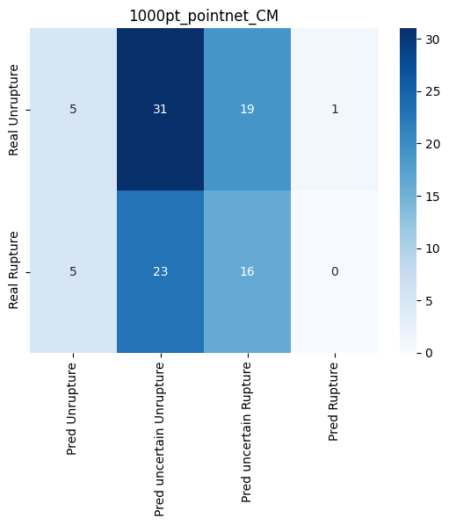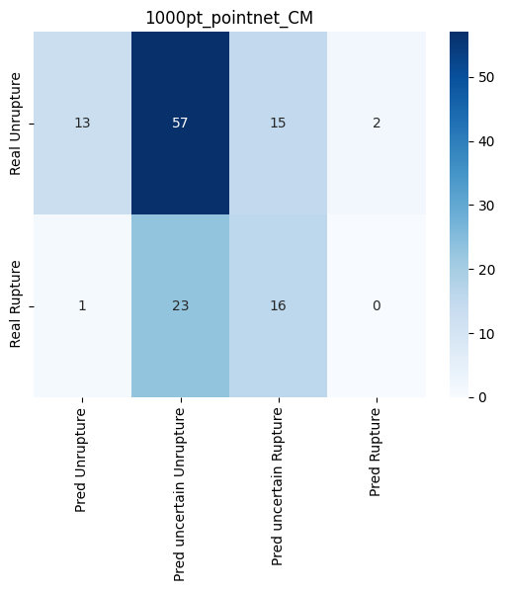

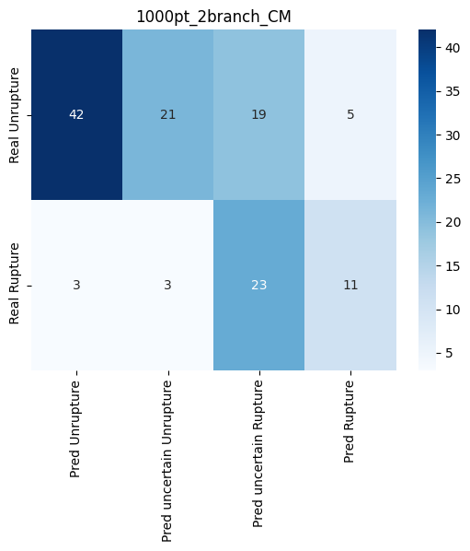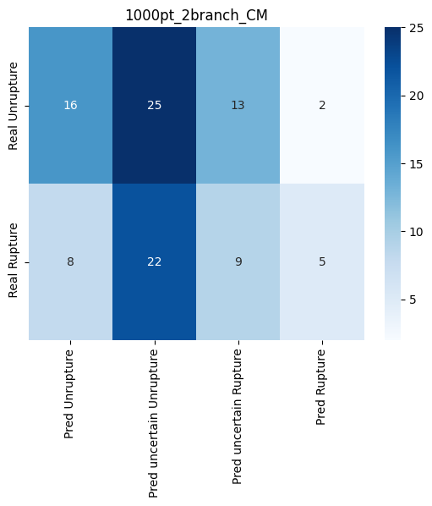

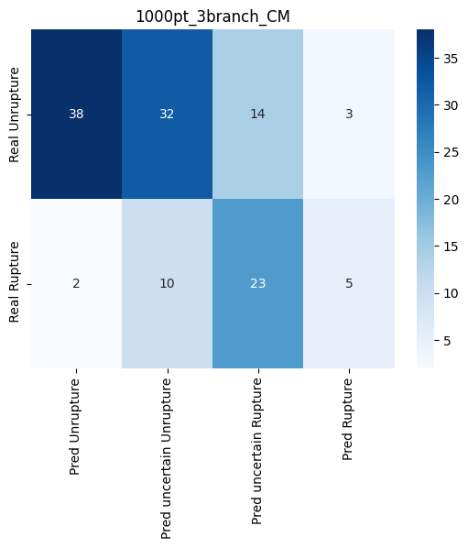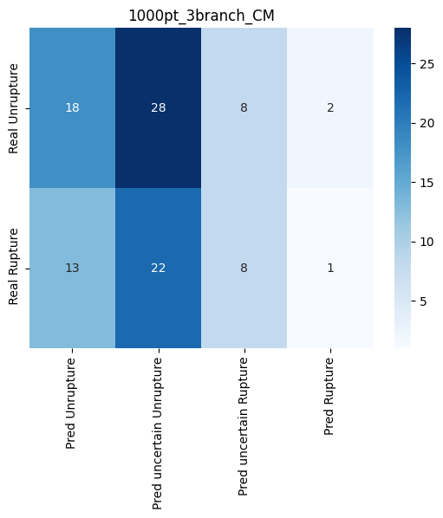

Ablation experiment

|  |  |  |  |  |  |  |  |
| --- | --- | --- | --- | --- | --- | --- | --- |
| uniform sampling 2000 points on 2branch model with cut1 | | | | | | | |
| Layer deleted | accuracy | AUC  (±0.02) | F1-score | Rupture Recall | Rupture Precision | Unrupture Recall | Unrupture Precision |
| None | **79.1%~83.3%** | **0.86** | **0.757** | **0.862** | **0.675** | **0.820** | **0.932** |
| Input transform | 70.8%~73.9% | 0.72 | 0.537 | 0.620 | 0.473 | 0.701 | 0.810 |
| Feature transform | 66.6%~70.8% | 0.79 | 0.562 | 0.620 | 0.514 | 0.746 | 0.819 |
| Final 2 fully connected layer | 78.1%~79.1% | 0.86 | 0.631 | 0.620 | 0.642 | **0.850** | 0.838 |
| 2 convolution layer in Tnet | 75%~79.1% | 0.84 | 0.612 | 0.655 | 0.575 | 0.791 | 0.841 |
| 2 convolution layer before merge | 75%~80.1% | 0.83 | 0.555 | 0.517 | 0.6 | 0.850 | 0.802 |
| 2 fully connect layer in Tnet | 78.1%~82.2**%** | 0.85 | 0.718 | 0.793 | 0.657 | 0.820 | **0.901** |

4.6 Evaluation

4.6.1 Evaluation methods

* Confusion matrix
* AUC
* P-value
* Accuracy

4.6.2 Mahine learning model Evaluation

#base on result evaluate the models

4.6.3 Deep Learning model Evaluation

Compare

PointNet and Basic DNN

2000 points vs 1000 points

1000 points Fps vs uniform sampling

1000 points 3 branch multimodal vs 2 branch multimodal vs 2 branch vs pointNet

# Chapter 5 Conclusion and Future Work

## 4.1 Conclusion

## 4.2 Limitation

Training on a relatively small dataset (735 data were used)

Missing information from transform mesh to point cloud, some vessel model have more than 20,000 vertices, but only take 1000 points from these using FSP

When add the vessel as a third branch for 3 branch model result become poor performance than 2 branch model, this is caused by the vessel model is not the vessel of whole brain, and each vessel model has large difference with each other, so in the external test which is Aneurisk data set, the vessel models have large difference with the vessel model used for training, so it cause the performance poorer then the 2 branch model.

This is because the vessel models in the dataset are only a small part that been cut from the whole brain vessel model, this will cause the training dataset have difference with test dataset

## 4.3 Future Work

Regulization for the pointNet, combine a stable Network with PointNet to make point Net become stable

# List of References

1. Jaehyuk Heo. et al. Prediction of Intracranial Aneurysm Risk using Machine Learning. Nature, Scientific reports (2020)
2. Peiying Li, Yongchang Liu. et al. A deep-learning method for the end-to-end prediction of intracranial aneurysm rupture risk. Patterns 4, 100709 (2023)
3. Kim, J. Y. et al. Executive Summary of Stroke Statistics in Korea 2018: A Report from the Epidemiology Research Council of the Korean Stroke Society. J Stroke 21, 42–59, <https://doi.org/10.5853/jos.2018.03125> (2019).
4. Kim, T. et al. Incidence and risk factors of intracranial aneurysm: A national cohort study in Korea. Int J Stroke 11, 917–927, https:// doi.org/10.1177/1747493016660096 (2016).
5. Lee, E. J. et al. Rupture rate for patients with untreated unruptured intracranial aneurysms in South Korea during 2006-2009. J Neurosurg 117, 53–59, <https://doi.org/10.3171/2012.3.JNS111221> (2012).
6. Kim, T., Kwon, O. K., Ban, S. P., Kim, Y. D. & Won, Y. D. A Phantom Menace to Medical Personnel During Endovascular Treatment of Cerebral Aneurysms: Real-Time Measurement of Radiation Exposure During Procedures. World Neurosurg, <https://doi>. org/10.1016/j.wneu.2019.01.063 (2019).
7. Kim HC, Rhim JK, Ahn JH, Park JJ, Moon JU, Hong EP, Kim MR, Kim SG, Lee SH, Jeong JH, et al. Machine Learning Application for Rupture Risk Assessment in Small-Sized Intracranial Aneurysm. *Journal of Clinical Medicine*. (2019);
8. Asari, S. & Ohmoto, T. Natural history and risk factors of unruptured cerebral aneurysms. Clin Neurol Neurosurg 95, 205–214 (1993).
9. Ronkainen, A. et al. Risk of harboring an unruptured intracranial aneurysm. Stroke 29, 359–362 (1998).
10. Hackenberg KAM, Hänggi D, Etminan N. Unruptured intracranial aneurysms. Stroke 49(9):2268–2275 (2018)
11. Algra AM, Lindgren A, Vergouwen MDI .et al. Procedural clinical complications, case-fatality risks, and risk factors in endo vascular and neurosurgical treatment of unruptured intracranial aneurysms: a systematic review and meta-analysis. JAMA Neurol 76(3):282–293(2019)
12. Mirzat Turhon .et al. Development and validation of a deep learning model for prediction of intracranial aneurysm rupture risk based on multi‑omics factor. European Society of Radiolog (2023)
13. Yang H, Cho K- C, Kim J- J, et al. Rupture risk prediction of cerebral aneurysms using a novel convolutional neural network- based deep learning model. J NeuroIntervent Surg 2023;15:200–204. (2022)
14. Cao H, Zeng H, Lv L, Wang Q, Ouyang H, Gui L, Hua P and Yang S, Assessment of intracranial aneurysm rupture risk using a point cloud-based deep learning model. Front. Physiol. 15:1293380. (2024)
15. Juchler, N., Bijlenga, P., & Hirsch, S. AneuX morphology database (v1.0) (2022). [Data set]. Zenodo. <https://doi.org/10.5281/zenodo.6678442>
16. R. Q. Charles, H. Su, M. Kaichun and L. J. Guibas, "PointNet: Deep Learning on Point Sets for 3D Classification and Segmentation," *2017 IEEE Conference on Computer Vision and Pattern Recognition (CVPR)*, Honolulu, HI, USA, 2017, pp. 77-85, doi: 10.1109/CVPR.2017.16.
17. Charles R. Qi, Li Yi, Hao Su, and Leonidas J. Guibas. PointNet++: deep hierarchical feature learning on point sets in a metric space. In Proceedings of the 31st International Conference on Neural Information Processing Systems (NIPS'17). Curran Associates Inc., Red Hook, NY, USA, 5105–5114.90. (2017)
18. Detmer FJ, Lückehe D, Mut F, Slawski M, Hirsch S, Bijlenga P, von Voigt G, Cebral JR. Comparison of statistical learning approaches for cerebral aneurysm rupture assessment. Int J Comput Assist Radiol Surg. 2020 Jan;15(1):141-150. doi: 10.1007/s11548-019-02065-2. Epub 2019 Sep 4. PMID: 31485987.
19. Jiaxin Li, Ben M. Chen, Gim Hee Lee; Proceedings of the IEEE Conference on Computer Vision and Pattern Recognition (CVPR), pp. 9397-9406 (2018)
20. Yifan Xu, Tianqi Fan, Mingye Xu, Long Zeng, and Yu Qiao. 2018. SpiderCNN: Deep Learning on Point Sets with Parameterized Convolutional Filters. In Computer Vision – ECCV 2018: 15th European Conference, Munich, Germany, September 8-14, 2018, Proceedings, Part VIII. Springer-Verlag, Berlin, Heidelberg, 90–105. (2018) <https://doi.org/10.1007/978-3-030-01237-3_6>
21. Wang J, Liu J, Xu Z, et al. N-PointNet: A multi-layer embedded deep learning model for 3D intracranial aneurysm classification and segmentation. Research Square; 2023. DOI: 10.21203/rs.3.rs-2760399/v1. (2023)
22. D. Shao, X. Lu and X. Liu, "3D Intracranial Aneurysm Classification and Segmentation via Unsupervised Dual-Branch Learning," in *IEEE Journal of Biomedical and Health Informatics*, vol. 27, no. 4, pp. 1770-1779, April 2023, doi: 10.1109/JBHI.2022.3180326. (2023)
23. X. Yang, D. Xia, T. Kin and T. Igarashi, "IntrA: 3D Intracranial Aneurysm Dataset for Deep Learning," *2020 IEEE/CVF Conference on Computer Vision and Pattern Recognition (CVPR)*, Seattle, WA, USA, 2020, pp. 2653-2663, doi: 10.1109/CVPR42600.2020.00273.(2020)
24. M. Ashtari-Majlan, A. Seifi and M. M. Dehshibi, "A Multi-Stream Convolutional Neural Network for Classification of Progressive MCI in Alzheimer’s Disease Using Structural MRI Images," in *IEEE Journal of Biomedical and Health Informatics*, vol. 26, no. 8, pp. 3918-3926, Aug. 2022, doi: 10.1109/JBHI.2022.3155705.

# Appendix A External Materials

<Level 1 Heading with ‘heading 1’ Style Applied by Pressing Ctrl Shift 1> Text under appendix heading. Text under appendix heading. Text under appendix heading. Text under appendix heading. Text under appendix heading. Text under appendix heading.

## A.1 Level 2 Heading with ‘heading 2’ Style Applied by Pressing Ctrl Shift 2

Text under level 2 heading. Text under level 2 heading. Text under level 2 heading. Text under level 2 heading.

### A.1.1 Level 3 Heading with ‘heading 3’ Style Applied by Pressing Ctrl Shift 3

Text under level 3 heading. Text under level 3 heading. Text under level 3 heading. Text under level 3 heading.

#### A.1.1.1 Level 4 Heading with ‘heading 4’ Style Applied by Pressing Ctrl Shift 4

Text under level 4 heading. Text under level 4 heading. Text under level 4 heading. Text under level 4 heading.

# Appendix B Ethical Issues Addressed

Text under appendix heading. Text under appendix heading. Text under appendix heading. Text under appendix heading. Text under appendix heading. Text under appendix heading.

## B.1 Level 2 Heading

Text under level 2 heading. Text under level 2 heading. Text under level 2 heading. Text under level 2 heading.